**Update – Centres experiencing issues accessing the SOLAR website Login and Candidate Access**

Some users have experienced an issue with the last update to the SurpassViewer. This issue will not allow the automatic opening of the Viewer when you interact with the Centre Login, Enter Keycode and the OpenAssess test options of the SOLAR website.

The resolution to this issue is to uninstall and to reinstall this software. (We understand that this may require your IT department if you do not have the required permissions)

**To uninstall as standard**

Use the Windows icon/ Settings/ Apps to scroll to find the SurpassViewer software

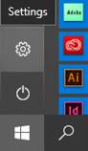

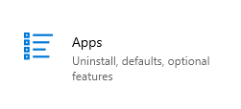

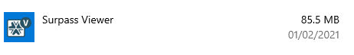

Once you find it, click it and the options to modify and un-install should appear

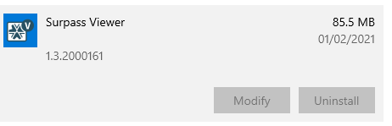

If you have the permissions to uninstall you can remove this from your machine and reinstall using the Guidance Documents section of the SOLAR website - <https://www.sqa.org.uk/mini/34442.html>

**Additional Information**

In a very small amount of cases the uninstall option has not worked. (We advise you to contact your IT to follow these steps)

Should the un-install option fail then the following steps should be taken:

* Remove all shortcuts from Start Menu and Task Bar
* Delete the folder BTL Group Ltd
* Reinstall from the Guidance Documents section of the SOLAR website - <https://www.sqa.org.uk/mini/34442.html>